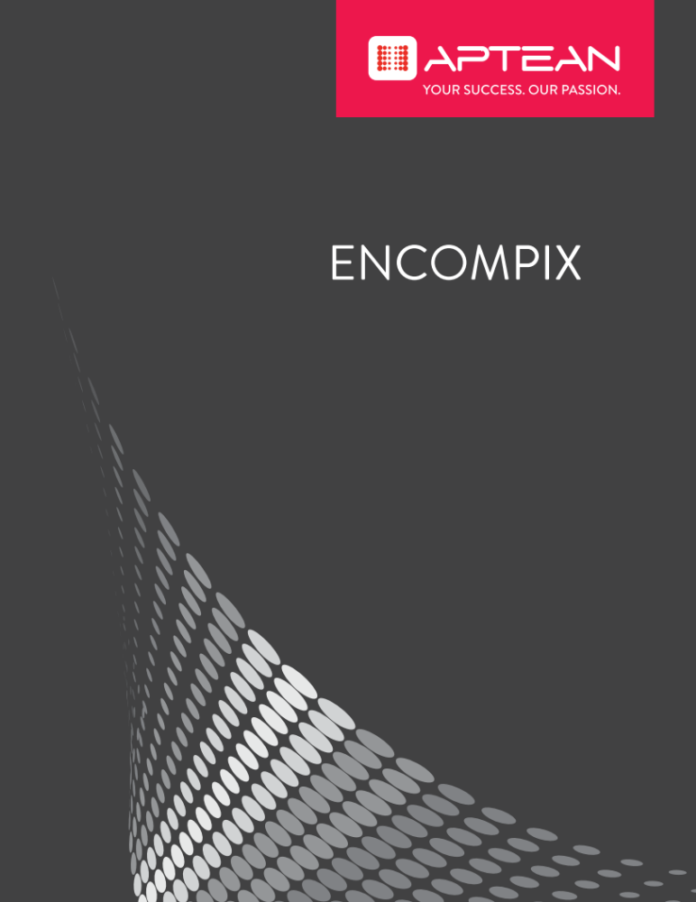

Onyx

Release Notes
Version 7.8
February 2017

Copyright © 2017 Aptean. All Rights Reserved. The information provided by Aptean in this document is for informational purposes only, without representation or warranty of any kind, and Aptean shall not be liable for errors or omissions with respect to the information. The only warranties for Aptean products and services are those set forth in the express warranty statements accompanying such products and services, if any, and nothing herein shall be construed as constituting an additional warranty. No part of this document shall be reproduced or transmitted in any form or for any purpose without the express written permission of Aptean. The information contained herein may be changed without prior notice. Some products marketed by Aptean contain proprietary software components of other software vendors. Aptean and other Aptean products and services referenced herein as well as their respective logos are registered trademark or trademarks of Aptean or its affiliated companies.
Contents

About this Release 2
Licensing Information 2
New Features 2
Edge Support 2
Enhanced UI Design 2
Onyx Insight 2
Software Development Kit (SDK) 3
Onyx Scripting 3
Navigator Enhancements 3
Onyx Mobile Enhancements 3
Onyx Mobile Web 4
Important Notice(s) 4
Technical Documentation 4
Fixes Included in this Release 5
Known Issues 7
Contacting Aptean Customer Support 7

About this Release
This Release Notes document provides information about the following:
- Licensing Information
- New Features
- Important Notice(s)
- Technical Documentation
- Fixes Included in this Release
- Known Issues
- Contacting Aptean Customer Support

Licensing Information
The number of users in Security Administration must not exceed the number of users allowed by your Onyx license agreement. When the number of concurrent users exceeds the number of Onyx licenses, no additional users can log on until a logged-on user logs off. If you need additional licenses, contact your Onyx Account Manager.

New Features
Onyx 7.8 contains enhancements that enable you to work more efficiently in Onyx. The enhancements made in this release are:
- Edge Support
The OEP 7.8 is now supported on Microsoft Edge.
- Enhanced UI Design
In Onyx 7.8, the UI design is enhanced to make the user’s interaction as simple and efficient as possible.
- Onyx Insight
Onyx Insight provides advanced search capability and easy search solutions that are scalable and reliable for different underlying enterprise products. It also enables you to extract live data from the search results and perform configured actions on the results. The search experience is greatly enhanced by the degree to which the response satisfies the user searching for information.
- Software Development Kit (SDK)
The Onyx 7.8 has a new Software Development Kit. The new Onyx SDK is a set of assemblies which facilitates interaction with the core business layer of Onyx (OEAS). The communication can be out of process across the network with core onyx security included. The data layer protocol of the Onyx SDK is Json, using NewtonSoft.net (Json.net); which does the serialization & deserialization of xml which is the core communication protocol in use.
- Onyx Scripting
  - Allows users to guide their interactions with customers.
  - Allows users to gather, create, update, or disseminate data across OEAS.
  - Allows users to call OEAS features to perform tasks, including those that require opening and working with OES Administration Workbench tools.
  - The Stand Alone Scripting allows users to access the Scripting application from a web browser or mobile.
- Navigator Enhancements
  - Select multiple items from the drop-down list on the Search Criteria pane.
  - Advance filter options on the Search Result window.
  - Tile view of search results on the Search Result window.
  - Update records from detail screens.
- Onyx Mobile Enhancements
  - Enhanced UI Design - The Onyx Mobile UI design is enhanced to make the user’s interaction as simple and efficient as possible.
  - Shortcut Handler – A new shortcut handler to launch Onyx Mobile from email or messages through URLs to view detail screens or scripts.
  - Prompted Action – A new Prompted Action to quickly update records on view screen.
  - Bar Code Scanning – A new bar code scanning to retrieve records and product information on the home screen and incident edit screen.
  - S3 Utility – A new utility to send emails, send signed emails, and store an attachments from incident screen.
  - Group Do More Actions – A new feature to group associated child actions under a parent action.
  - Scripting - Support for Sencha scripting module.
  - Supports iOS 9.0 and higher versions.
  - Supports Android 5.0 and higher versions.
- Onyx Mobile Web
  - Enhanced UI Design - The Onyx Mobile UI design is enhanced to make the user’s interaction as simple and efficient as possible.
  - Shortcut Handler – A new shortcut handler to launch Onyx Mobile from email or messages through URLs to view detail screens or scripts.
  - Prompted Action – A new Prompted Action to quickly update records on view screen.
  - Group Do More Actions – A new feature to group associated child actions under a parent action.
  - Scripting - Support for Sencha scripting module.

Important Notice(s)
Upgrade of the following Onyx core components from earlier versions to version 7.8 is not supported:
- Onyx Employee Portal
- Onyx Enterprise Studio
Note: These installations require an uninstall of earlier versions first, followed by an installation of version 7.8.

Technical Documentation
In addition to these Release Notes, the following documents are included in this release:
- Onyx 7.8 CTI Toolbar Implementation Guide
- Onyx 7.8 CTI Toolbar Developer's Reference Guide
- Onyx 7.8 OEAS Technical Reference Guide
- Onyx 7.8 OEP Administration Guide
- Onyx 7.8 Analytics Installation Guide
- Onyx 7.8 Onyx Employee Portal User Guide
- Onyx 7.8 Installation Guide
- Onyx 7.8 Onyx Mobile Administration Guide
- Onyx 7.8 Onyx Mobile User Guide
- Onyx 7.8 Onyx360Help
- Onyx 7.8 SDK Document
- Onyx 7.8 System Requirements Guide
- Onyx 7.8 Onyx Gateway Proxy Deployment Guide
- Onyx 7.7 to 7.8 Upgrade Procedures

Fixes Included in this Release
The following customer-reported bugs and hotfixes are fixed in this release.
Internal Number | Description
81030 | Application Error on ONYXSM.DLL when the value of resource_significant_bit exceed 1024.
204246 | SQL syntax error appears when displaying history on Powerpage.
216991 | Unable to open the attachments uploaded from Onyx Mobile App.
246529 | Navigator - Search Criteria - Tracking Code Not Displaying List if the campaign code includes &.
246526 | Onyx 7.7 SP2 - Script Error.
246525 | Navigator - Date Format - Home Screen - Displays US Date Time Format for same query.
241207 | Team Member query search returns different results in OEP Navigator and Onyx Mobile.
218359 | Security issue with delta_merge_xmlhttp.
172736 | List Scroll number resulted from Navigator search is displayed on the incident all the time.
211489 | date field in list manager result is UTC time.
135518 | oeplog object doesn't work.
200608 | 2 character length property throws the error in Object Designer.
191661 | the extension of pdf changed to f after imported by OPS.
172758 | Problem related to the number of security resources.
172766 | Need search function for OES security managment.
238564 | invalid script configuration crashes dllhst3g.exe from module onyxscriptenginestep.dll.
231286 | OPS (subsystem) start/stop issues.
200609 | Org Chart – Issue.
221453 | Onyx Phone Control - Tab Index Issue.
224982 | Navigator - Configuration of the message box.
228011 | Some characters not allowed in e-mail addresses.
101853 | Onyx7.5 Navigator - search operator string overlapped when using tab key.
123492 | 7.5 - SQL syntax error appears when searching from Navigator.
125089 | 7.5- Navigator - Error when cloning certain type of records.
246524 | Emailing Label Oupt Problem.
241206 | Customizing the Company and Individual Search for Onyx Mobile.
91703 | error when result grid filed in details area has single quote mark in its display name.
96297 | Onyx7.5 Navigator and Homepage filter returned different search result when using ANY on date.
176094 | Application error is logged intermittently when stop OPS service.
231405 | OPS (EMS) throws the error when processing emails with certain charset.
250967 | Cannot Delete OR Update Public Query.
208162 | hotfix 24199 resize doesn't work when onyx window is in a window with more than one tab.
215524 | OEDB 7.5 installer does not detect correct database version.
212798 | Using Windows Authentication does not establish session from LBO tester.
194273 | Navigator - grouping function.
231670 | Navigator - Queries - A Saved Query on Load populates any User Picker control with all users in the.
217349 | Link text to merge templates is inconsistent confusing.
195492 | OGS password encryption issues.
217350 | Customer Name and Owner Id links are not clearly visible on the Task screens.
217955 | Onyx User Preferences - General - Default Worknotes View - Not Working.
211014 | date field in list manager result is UTC time.
213842 | Cummulative Hotfix returns error when Homepage displays the saved query which include Date type.
224980 | Navigator/Silverlight Application Storage.
225788 | Navigator Home Page filter does not mask column.
241373 | Last Comment shows white space for some worknotes.
226522 | Watch/Unwatch behavior issue.
213628 | Need Hotfix 100084 including private hotfix 99930.
224983 | Navigator Search Does Not Include InsertBy/UpdateBy when choosing Group.
224981 | Navigator does not return appropriate result when searching by Tracking Code.

Known Issues
The following is a list of known issues in this release.
Internal Number | Description
259017 | OEP: Column header width cannot be increased using drag and drop on Bottom RLC menu.
260041 | OEP: Survey: &, ', ", < and > are not encoded when opening from survey tab for Text Box field.
249942 | Scripting: Control: All Control Example: List box value is not displayed on the view result step.
218182 | Onyx Mobile (iOS): Not possible to change dependency dropdown value from a blank value in prompted action.
216995 | Pictures are located strangely when opening it from OEP desktop.
260652 | OnyxMobile: iOS: Prompted actions do more control goes blank.
263548 | OEP: Survey : Data in Editable textbox for checkbox and drop-down controls is not saving.
263522 | Ecmas: “Insert OEP hyperlink” in email page is not working as expected when workticket or email link is added in edge browser.
263757 | Literature: Adding literature is throwing error.
263926 | Navigator: The search criteria fields in the saved query varies based on the currently selected fields in the search criteria.

Contacting Aptean Customer Support
For operational or technical questions related to Onyx CRM, contact Aptean Customer Support at http://support.aptean.com/selfservice/.

